ПРИМЕР ЗАПОЛНЕНИЯ АНКЕТЫ НА ТУРИСТИЧЕСКУЮ ВИЗУ ВО ФРАНЦИЮ

N° 14076*01

Application for Schengen visa

This application form is free

- Surname (Family name) (x) IVANOVA
- Surname at birth (Former family name(s)) (x) PETROVA
- First name(s) (Given name(s)) (x) SVETLANA
4(day-month-year) . Date of birth 5. Place of birth : Moscow 7. Current nationality : RF
02-04-1982 6. Country of birth : USSR Nationality at birth, if different: : USSR
8. Sex 9. Marital Status
Male X Female Single Other (please specify) X Married Separated Divorced Widow(er)
- In the case of minors: Surname, first name, address (if different from applicant's) and nationality of parental authority/legal guardian

- National identity number, where applicable :
- Type of travel document
X Ordinary passport Diplomatic passport Service passport Official passport Special passport Other travel document (please specify) :

- Travel document number 14. Date of issue 15. Valid until 16. Issued by
71 1234567 01/04/2011 01/04/2021 FMS 001

- Applicant's home address and e-mail address Telephone number(s) 111111, RUSSIA, MOSCOW, MOSKOVSKAYA STR. 4,
APT.1 +7 900 111 2233
IVANOVASVETA@EMAIL.RU
- Residence in a country other than the country of current nationality
X No Yes : Residence permit or equivalent N°………………….…….……Valid until………………..….

- 19. Current occupation MANAGER
- 20. Employer and employer's address and telephone number. For students, name and address of educational
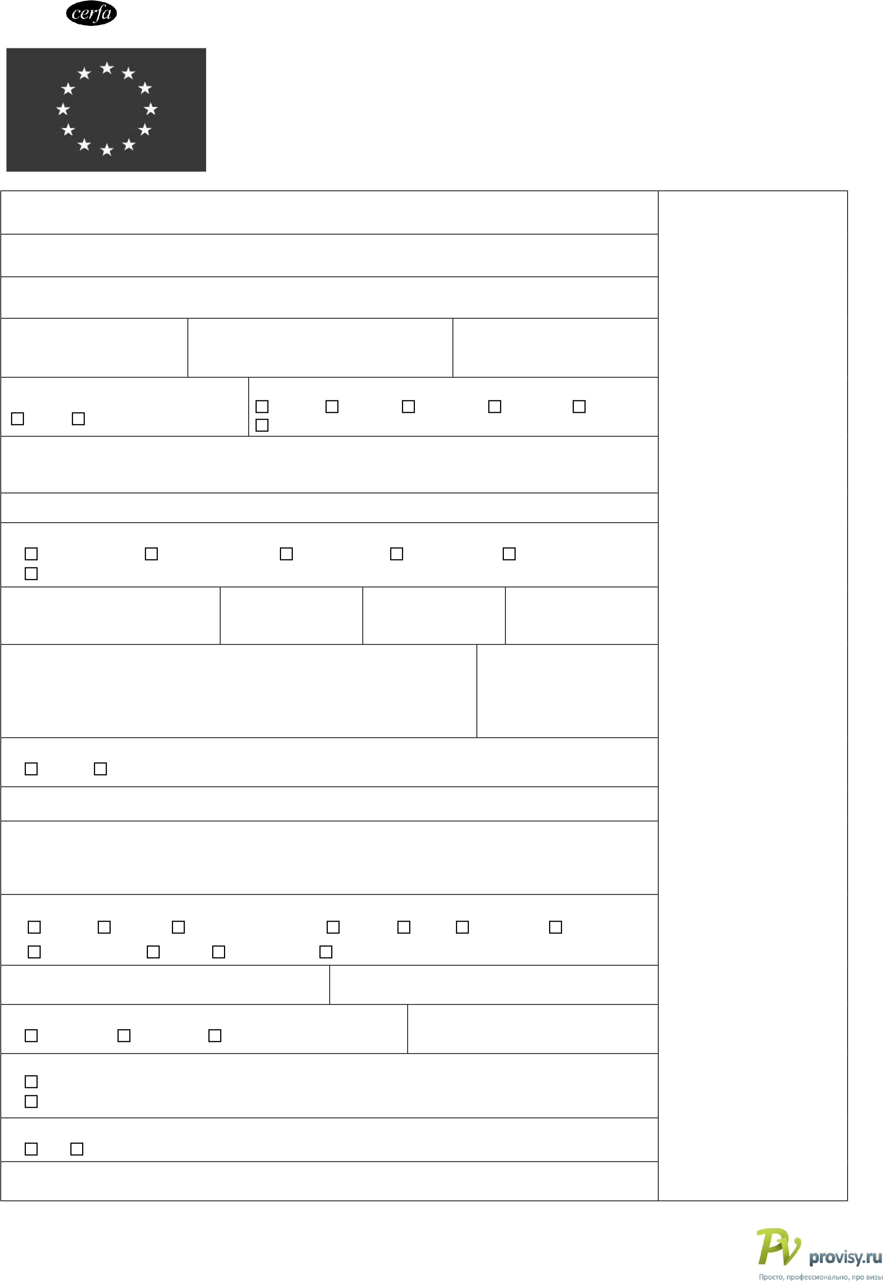
^{establishment.} "COMPANY" LLC - 111111, RUSSIA, MOSCOW, CENTRALNAYA STR. 4 TEL. +7 495 444 5566 , FAX +7 495 444 5577
- Main purpose(s) of the journey :
X Tourism Business Visiting family or friends Cultural Sports Official visit Study Medical reasons Transit Airport transit Other (please specify ) :

- Member State(s) of destination 23. Member State of first entry

FRANCE FRANCE
24. Number of entries requested 25. . Duration of the intended stay or transit X Single entry Two entries Multiple entries Indicate number of days : 12
- Schengen visas issued during the past three years
No
  - Yes. Date(s) of validity ………………/…………….., …….…….…/………………, …..………../…………… 25-04-2012 27-04-2012
- Fingerprints collected previously for the purpose of applying for a Schengen visa
  - No Yes. Date, if known : ……………………………………………………………….
- Entry permit for the final country of destination, where applicable
PHOTO

For official use only
Date of application :

Visa application number :

File handled by :

Application lodged at :
□ Embassy/consulate
□ CAC
□ Service provider
□ Commercial intermediary
□ Border

Name :

□ Other

Supporting documents :

□ Travel document
□ Means of subsistence
□ Invitation
□ Means of transport
□ TMI
□ Other:

Visa decision :
□ Refused

□ Issued :
□ A □ C
□ LTV

□ Valid :

From…………………………

Until………………………….

Number of entries :
□ 1 □ 2 □ Multiple

Number of days : …………….

Issued by……………………………….………, valid from……………………………..until……………………………
* The fields marked with * do not need to be filled in by family members of EU, EEA or CH citizens (spouse, child or dependent ascendant) while exercising their right to free movement. Family members of EU, EEA or CH citizens shall present documents to prove this relationship and fill in fields no 34 and 35.

(x) Fields 1-3 shall be filled in in accordance with the data in the travel document.

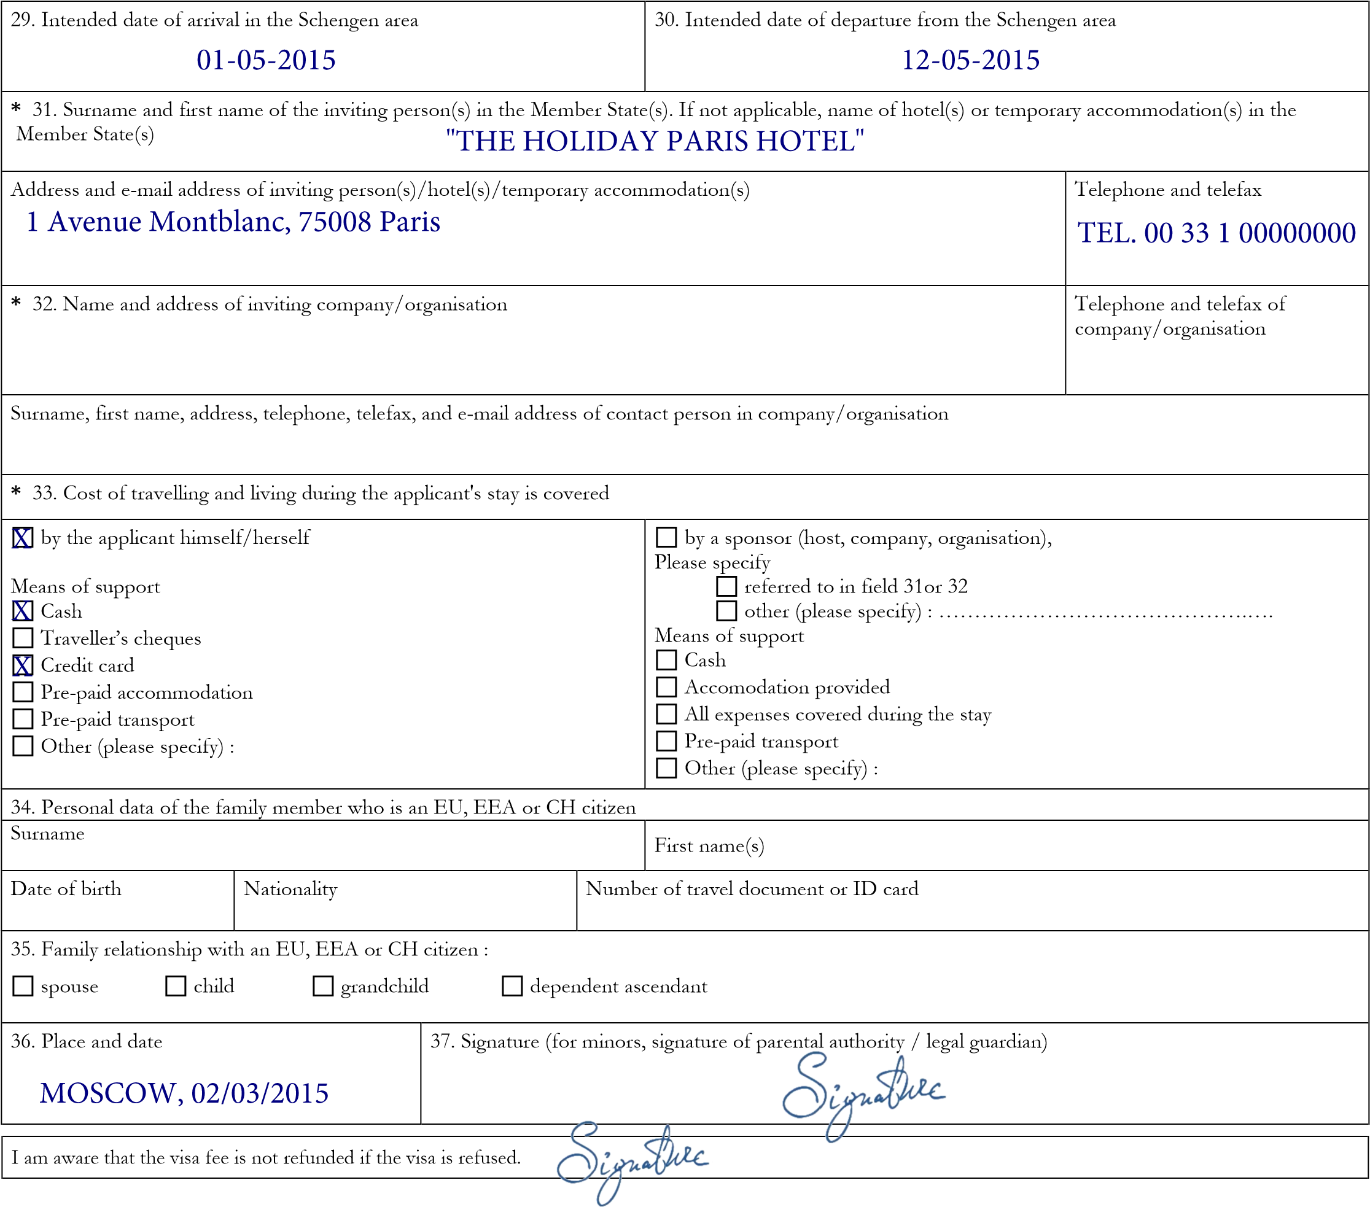Applicable in case a multiple-entry visa is applied for (cf. field no 24): СТАВИМ ПОДПИСЬ ПРИ ЗАПРОСЕ МНОГОКРАТНОЙ ВИЗЫ
I am aware of the need to have an adequate travel medical insurance for my first stay and any subsequent visits to the territory of Member States.

I am aware of and consent to the following: the collection of the data required by this application form and the taking of my photograph and, if applicable, the taking of fingerprints, are mandatory for the examination of the visa application; and any personal data concerning me which appear on the visa application form, as well as my fingerprints and my photograph will be supplied to the relevant authorities of the Member States and processed by those authorities, for the purposes of a decision on my visa application.
Such data as well as data concerning the decision taken on my application or a decision whether to annul, revoke or extend a visa issued will be entered into, and stored in the Visa Information System (VIS) for a maximum period of five years, during which it will be accessible to the visa authorities and the authorities competent for carrying out checks on visas at external borders and within the Member States, immigration and asylum authorities in the Member States for the purposes of verifying whether the conditions for the legal entry into, stay and residence on the territory of the Member States are fulfilled, of identifying persons who do not or who no longer fulfil these conditions, of examining an asylum application and of determining responsibility for such examination. Under certain conditions the data will be also available to designated authorities of the Member States and to Europol for the purpose of the prevention, detection and investigation of terrorist offences and of other serious criminal offences. The authority of the Member State responsible for processing the data is: Commission Nationale de l'Informatique et des Libertés – 8, rue
Vivienne – 75083 PARIS cedex 02
I am aware that I have the right to obtain in any of the Member States notification of the data relating to me recorded in the VIS and of the Member State which transmitted the data, and to request that data relating to me which are inaccurate be corrected and that data relating to me processed unlawfully be deleted. At my express request, the authority examining my application will inform me of the manner in which I may exercise my right to check the personal data concerning me and have them corrected or deleted, including the related remedies according to the national law of the State concerned. The national supervisory authority of that Member State (Commission Nationale de l'Informatique et des Libertés – 8, rue Vivienne – 75083 PARIS cedex 02) will hear claims concerning the protection of personal data.
I declare that to the best of my knowledge all particulars supplied by me are correct and complete. I am aware that any false statements will lead to my application being rejected or to the annulment of a visa already granted and may also render me liable to prosecution under the law of the Member State which deals with the application.
I undertake to leave the territory of the Member States before the expiry of the visa, if granted. I have been informed that possession of a visa is only one of the prerequisites for entry into the European territory of the Member States. The mere fact that a visa has been granted to me does not mean that I will be entitled to compensation if I fail to comply with the relevant provisions of Article 5(1) of Regulation (EC) No 562/2006 (Schengen Borders Code) and I am therefore refused entry. The prerequisites for entry will be checked again on entry into the European territory of the Member States.

Place and date  MOSCOW, 02/03/2015 | Signature (for minors, signature of parental authority/legal guardian):
(1) Insofar as the VIS is operational 



